**INFO20003 Database System Project2  
Juntong Angel Tan student ID: 987979**

**Q1**. Find all the ongoing/unfinished steps. Display the title of these steps and full names of the users who are taking these steps.

SELECT step.title, CONCAT(user.first_name, ' ', user.last_name) AS full_name

FROM step

INNER JOIN step_taken ON step.stepID = step_taken.step_id

INNER JOIN user ON step_taken.user_id = user.userID

WHERE step_taken.when_finished IS NULL;

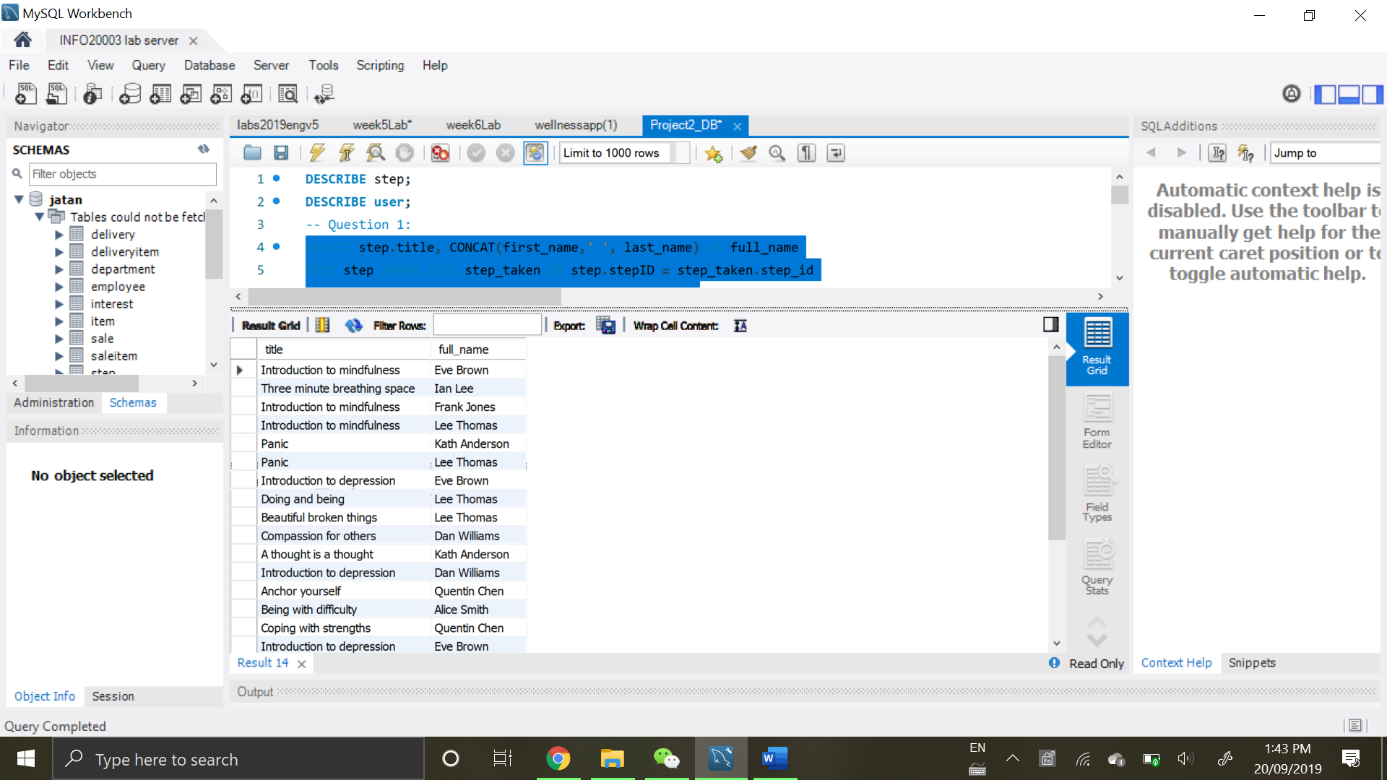

24 rows returned

**Q2**. List the themes and the number of the steps associated with these themes. Display the theme name and number of associated steps sorted in descending order.

SELECT theme.name, COUNT(DISTINCT step_id) AS count_steps

FROM theme LEFT JOIN step_theme ON theme.themeID = step_theme.theme_id

GROUP BY name

ORDER BY count_steps DESC;

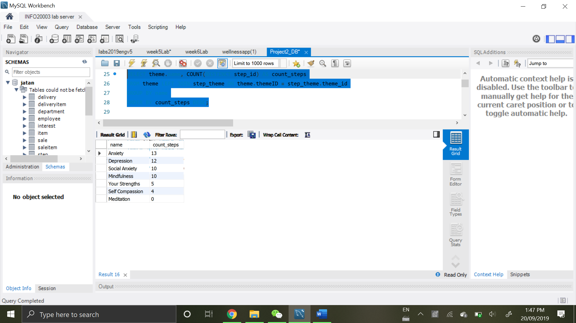

7 rows returned

**Q3**. Which step is the least popular based on the average rating given by users? Display the title and ID of the step and its average rating(formatted to 2 decimal places). Only include those steps which are rated by at least one user.

SELECT step.title, step.stepID, FORMAT(AVG(step_taken.rating), 2) AS avg_rating

FROM step INNER JOIN step_taken ON step.stepID = step_taken.step_id

GROUP BY step_id

ORDER BY avg_rating

LIMIT 1;

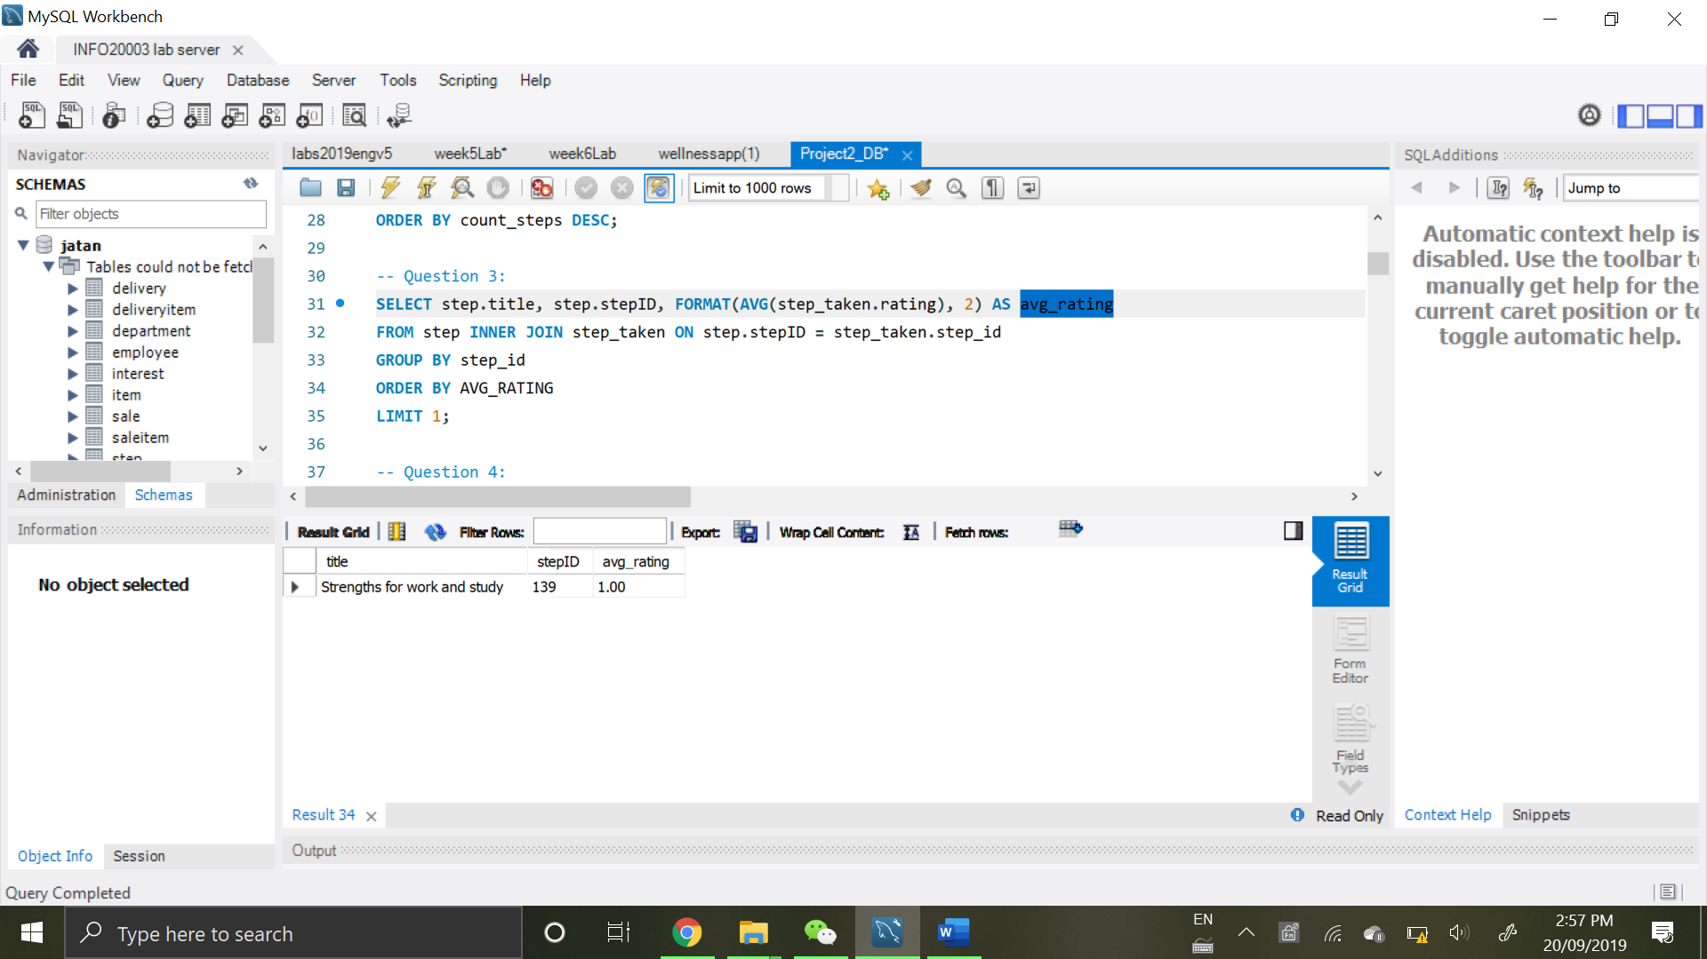

1 row returned

**Q4**. Find the steps that are taken the greatest number of times. Display the ID, title and count of the times the step has been taken. In case of ties, display all the steps with the same number of times taken.

SELECT step.stepID, step.title, COUNT(*) AS count_of_time

FROM step INNER JOIN step_taken ON step.stepID = step_taken.step_id

GROUP BY stepID

HAVING count_of_time = (SELECT COUNT(*) AS count_of_time

FROM step_taken

GROUP BY step_id

ORDER BY count_of_time DESC

LIMIT 1);

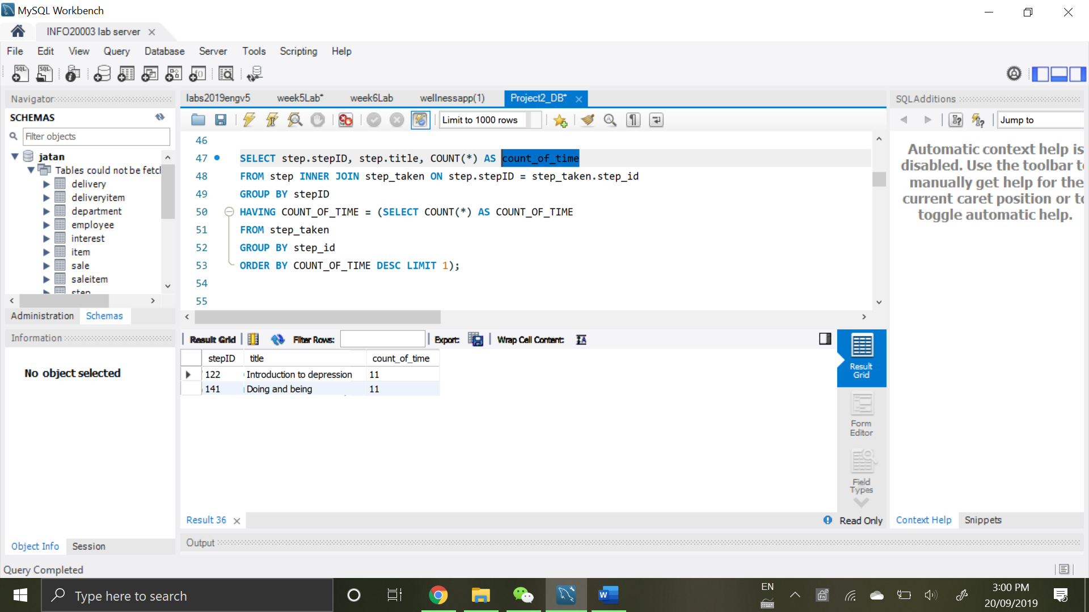

2 rows returned

**Q5**. Who is the most followed user between age of 15 and 18? Display the age(as an integer), first name, and last name of such user along with the number of followers.  
(assumption: “*there will only be one user with the highest number of followers*” from discussion board )

SELECT FORMAT(TIMESTAMPDIFF(YEAR, DOB, CURDATE()), 0) AS age,

user.first_name, user.last_name, COUNT(*) AS num_followers

FROM user INNER JOIN user_follow ON user.userID = user_follow.followed_user_id

GROUP BY first_name, last_name, age

HAVING age >= 15 AND age <= 18

ORDER BY num_followers DESC

LIMIT 1;

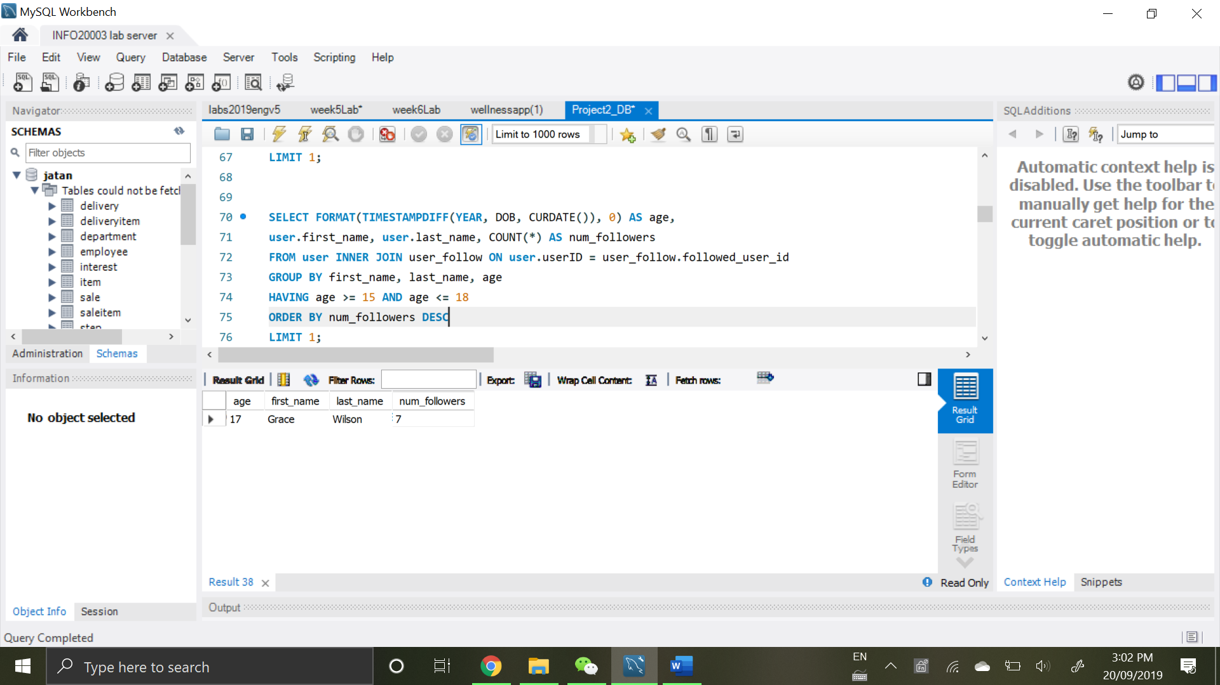

1 row returned

**Q6**. Find all steps that are never taken or are taken exactly once? Display the id and title of these steps along with the indication how many times the step has been taken(0 or 1)

SELECT stepID, step.title, SUM(IF(step_taken.id IS NULL, 0, 1)) AS times_taken

FROM step LEFT OUTER JOIN step_taken ON step.stepID = step_taken.step_id

GROUP BY stepID, title

HAVING times_taken = 0 OR times_taken = 1;

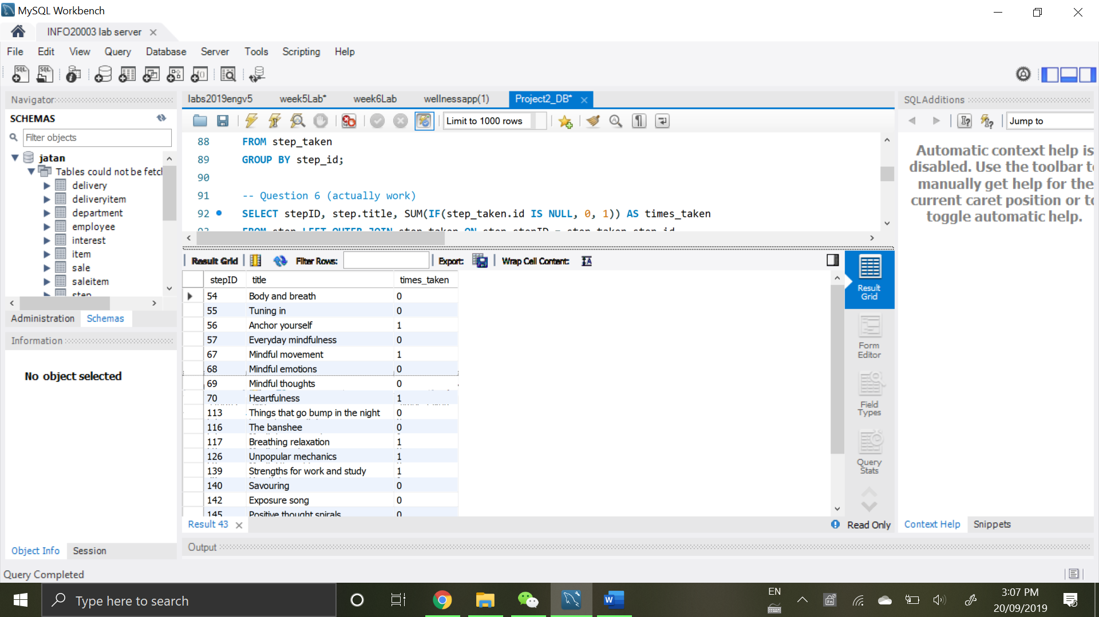

20 rows returned

**Q7**. Find users who started taking step ‘Doing and being’ after they had started the step ‘Panic’ but have never completed ‘Panic’. Display the user ID, first name and last name.

SELECT DISTINCT user.userID, user.first_name, user.last_name

FROM user

INNER JOIN

(SELECT user_id, when_started, when_finished

FROM step INNER JOIN step_taken ON step.stepID = step_taken.step_id

WHERE step.title = 'Panic') AS step_panic

ON user.userID = step_panic.user_id

INNER JOIN

(SELECT user_id, when_started

FROM step INNER JOIN step_taken ON step.stepID = step_taken.step_id

WHERE step.title = 'Doing and being') AS step_doing

ON step_panic.user_id = step_doing.user_id

WHERE timestampdiff(SECOND, step_panic.when_started, step_doing.when_started) > 0

AND NOT EXISTS (SELECT 1 FROM step_taken

INNER JOIN step ON step_taken.step_id = step.stepID

WHERE step_taken.when_finished IS NOT NULL

AND step.title = 'Panic'

AND step_taken.user_id = user.userID);

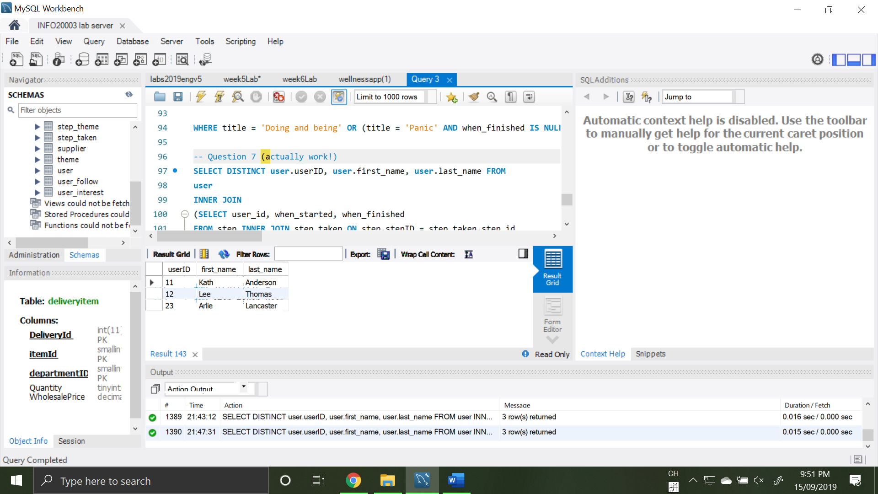

3 rows returned

**Q8.** What finished steps were completed both by a user with first name “Alice” and a user with first name “Bob”? Display the ID and title of such steps along with the number of times each user has completed these steps.

SELECT step.stepID, step.title,

SUM(IF(user.first_name = 'Alice', 1, 0)) AS alice_counts,

SUM(IF(user.first_name = 'Bob', 1, 0)) AS bob_counts

FROM step

INNER JOIN step_taken ON step.stepID = step_taken.step_id

INNER JOIN user ON step_taken.user_id = user.userID

WHERE (user.first_name = 'Alice' OR user.first_name = 'Bob')

AND step_taken.when_finished IS NOT NULL

GROUP BY stepID

HAVING alice_counts > 0 AND bob_counts > 0;

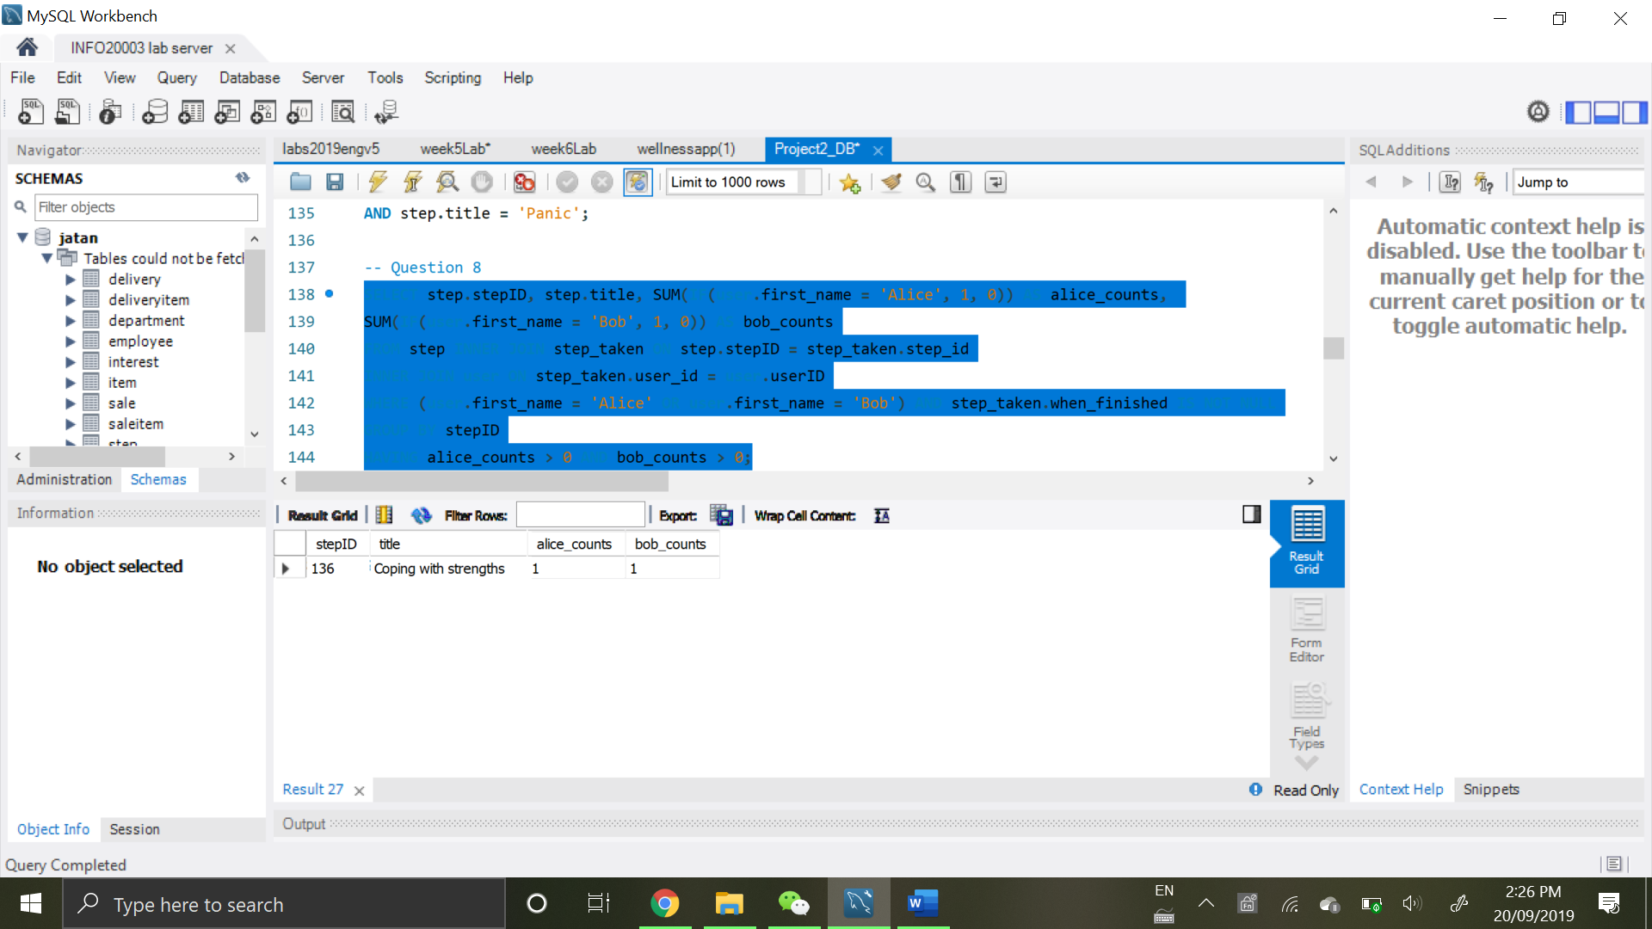

1 row returned

**Q9.** Find the top two users with the highest number of interests. For those two users, find out the common steps taken by both of them. Display the titles of the common steps they have taken and the number of times those steps are taken by each user.

SELECT step.title,

SUM(IF(most_interests.user_id IS NOT NULL, 1, 0)) AS most_interests_count,

SUM(IF(second_most_interests.user_id IS NOT NULL, 1, 0)) AS second_most_interests_count

FROM step

INNER JOIN step_taken ON step.stepID = step_taken.step_id

LEFT OUTER JOIN

(SELECT user_id

FROM user_interest

GROUP BY user_id

ORDER BY COUNT(*) DESC

LIMIT 1) AS most_interests

ON step_taken.user_id = most_interests.user_id

LEFT OUTER JOIN

(SELECT user_id

FROM user_interest

GROUP BY user_id

ORDER BY COUNT(*) DESC

LIMIT 1 OFFSET 1) AS second_most_interests

ON step_taken.user_id = second_most_interests.user_id

GROUP BY step.stepID

HAVING most_interests_count > 0 AND second_most_interests_count > 0;

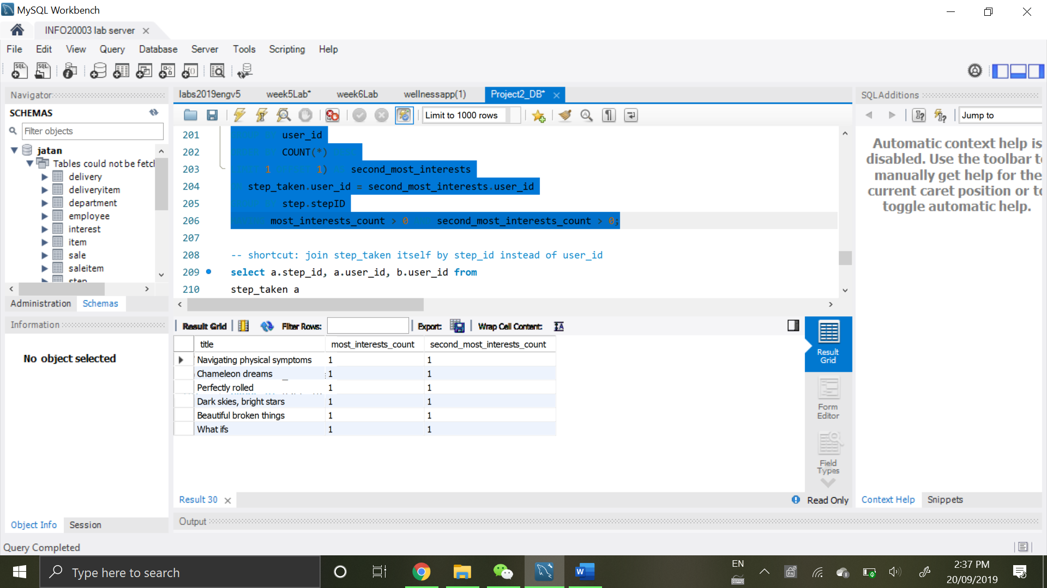

6 rows returned

**Q10.** For each user taking a step, calculate how many other users have taken the same step. We are only interested in the cases where the step is performed by at least 5 other users. Display the user ID, number of other users (at least 5 other users) who are taking the same step and the title of the taken step.

SELECT DISTINCT step_taken.user_id, step.title,

COUNT(DISTINCT step_taken_other.user_id)-1 AS count_other_users

FROM step

INNER JOIN step_taken

ON step.stepID = step_taken.step_id

INNER JOIN step_taken AS step_taken_other

ON step_taken.step_id = step_taken_other.step_id

GROUP BY user_id, title

HAVING (count_other_users) >= 5;

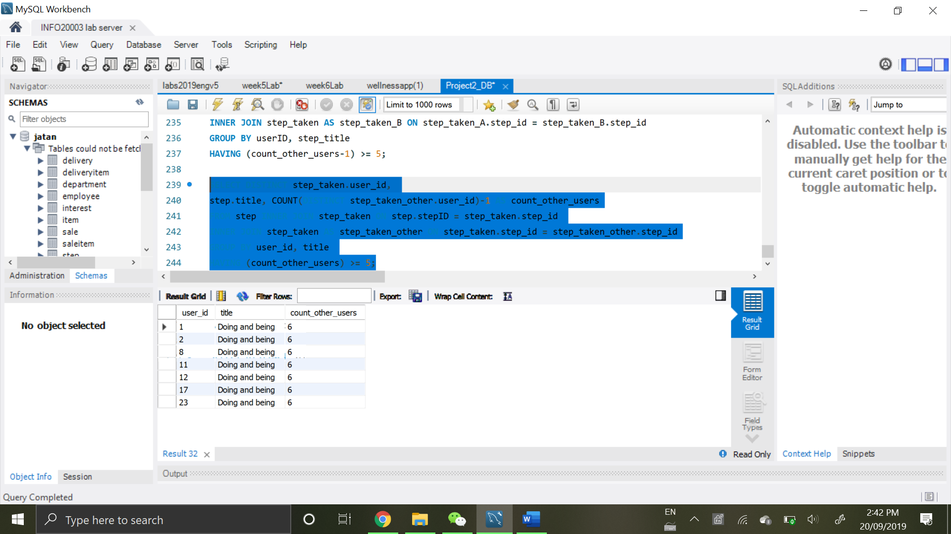

7 rows returned